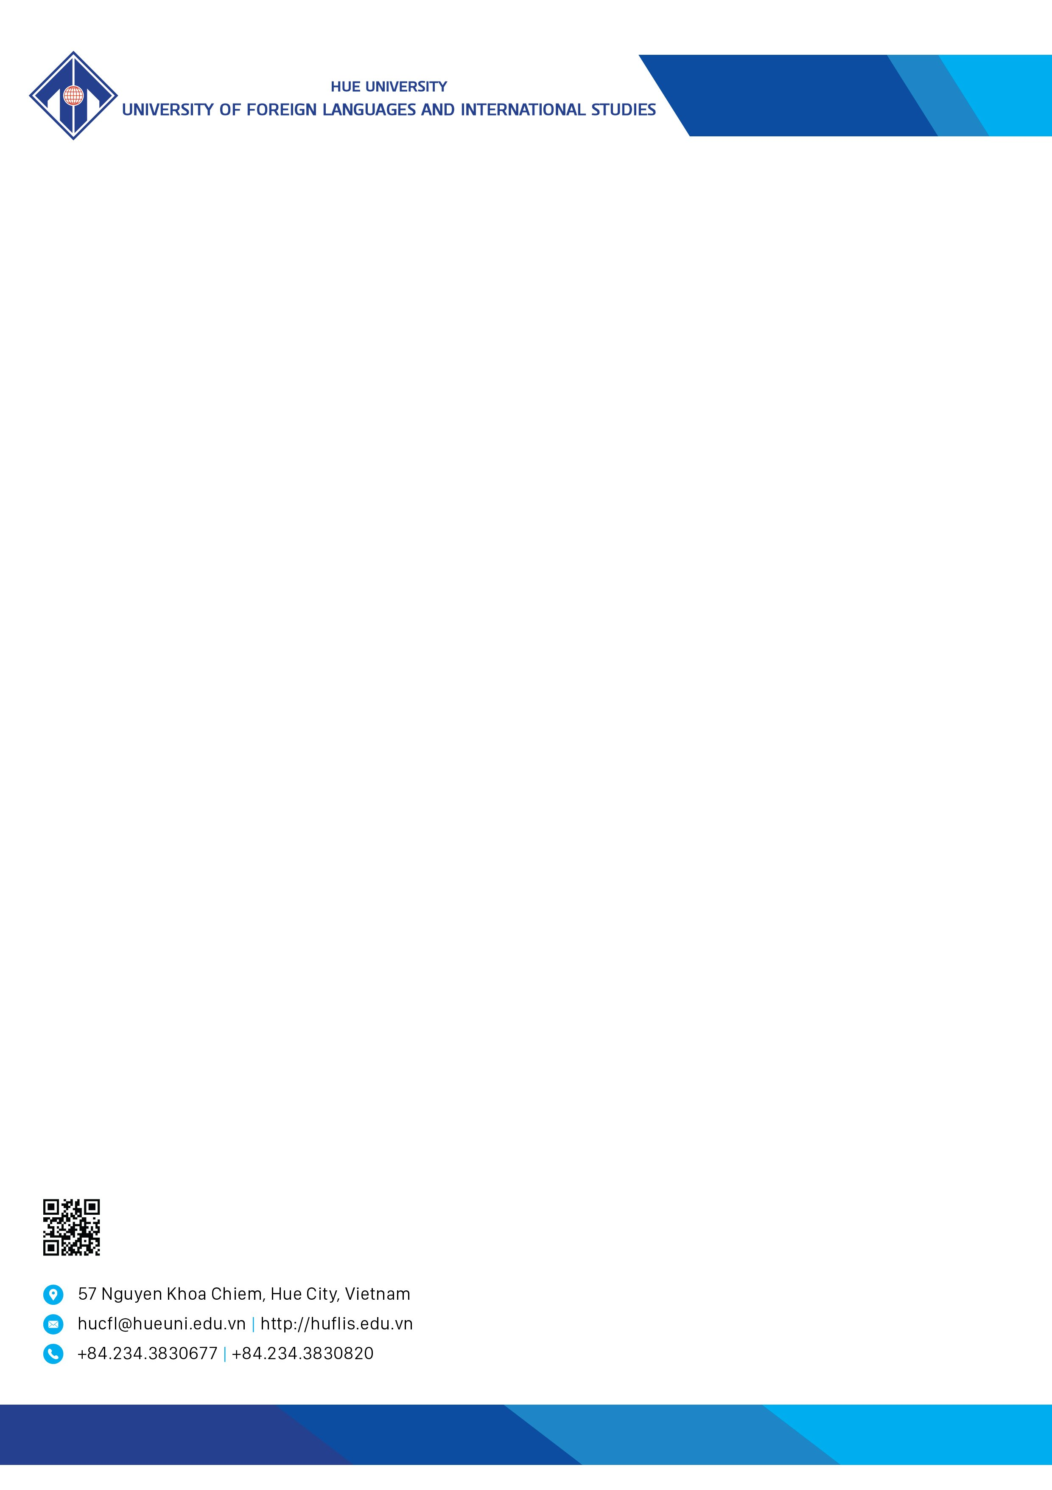

CALL FOR PAPERS

THE 12TH INTERNATIONAL CONFERENCE ON INTERDISCIPLINARY RESEARCH IN LINGUISTICS AND LANGUAGE EDUCATION, 2026

- About the conference
The Conference on Interdisciplinary Research in Linguistics and Language Education is a prestigious annual academic activity organized by the University of Foreign Languages and International Studies, Hue University, in conjunction with its domestic and international partners.
The 12th Conference this year is a specialized gathering that brings together linguists, language researchers, educators and enthusiasts. The event gives room for them to exchange research results and discuss future trends and directions in research in linguistics and language education.
- Call for papers
- Conference Theme: Empowering Futures: Navigating Agency, Identity, and Generative AI for Sustainable Language Education
- Relevant abstracts and manuscripts of original research that have not been published or submitted elsewhere are welcomed. Abstracts and manuscripts are written in either English or Vietnamese in accordance with, but not limited to, the following topics:
- Linguistics and Translation Studies;
- Language Teaching Pedagogy and Assessment;
- Language Policy and K-12 Language Education;
- Professional Development;
- Language, Identity and Intercultural Communication;
- Technology and Generative AI in Language Education;
- English as a Medium of Instruction (EMI).

- Important dates
- Abstract submission deadline: June 1, 2026. Please use the following form to submit your abstract: https://forms.gle/h7iT6v2WgX9oXMxv7
The expected date for the review decision is June 25, 2026.
- Registration deadline for presenters and participants (including fee payment): June 30, 2026. Register at: https://forms.gle/3KTFrFtjMCHeMjKCA
- Registration fee and payment method
- Registration fee: 23 USD.
- Payment period: From June 1, 2026, to June 30, 2026.
- Payment method: Bank transfer.
Bank account:
- Account Holder's Name: Trường Đại học Ngoại ngữ
- Bank Account Number:122000014732
- Bank Name & Address: Vietnam Joint Stock Commercial Bank for Industry and Trade – Branch (Vietinbank Hue Branch)
- Bank SWIFT Code: ICBVVNVX460
- Structure of the transaction:
“Full Name - Affiliation - ID Number - Registration Fee LN12 – Email”
NOTES:
- Bank transfers are processed during business hours: 8:00 AM–4:30 PM. Transfers will not be processed on Saturdays or Sundays.
- If you require an invoice, please provide all necessary information (including individual/organization name, tax code, etc.) via this link: https://forms.gle/1iQ7WWLMXq4C65nj6 before making your payment.
- Participants are responsible for their own travel, accommodation, and other related expenses.
- Language at the conference: Vietnamese and English

- Contact
Office of Research Management and International Cooperation
Address: 57 Nguyen Khoa Chiem St., Hue City, Vietnam
Email: dhnn_hoithao@hueuni.edu.vn
Phone number of 0234.3.830.722.
Hue, March , 2026
RECTOR

PHAM THI HONG NHUNG

